Bluetooth Mouse
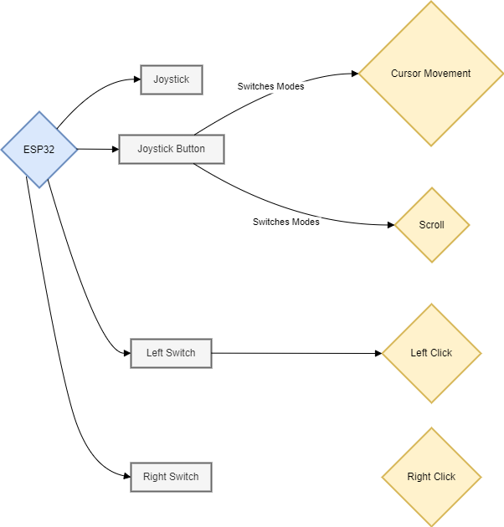
Overview
This diagram illustrates the architecture of a Bluetooth mouse using an ESP32 microcontroller. The
mouse features a joystick for cursor movement and tactile switches for left and right clicks. The joystick
button toggles between cursor movement and scroll mode.

Components
1. ESP32
2. Joystick
3. Joystick Button
4. Left Switch (Tactile Switch)
5. Right Switch (Tactile Switch)
Functional Connections
ESP32 to Joystick:
- The joystick sends analog signals to the ESP32, which processes these signals to control
cursor movement on the connected device.
ESP32 to Joystick Button:
- The joystick button sends a digital signal to the ESP32, which toggles between cursor
movement and scroll mode.
ESP32 to Left Switch:
- The left tactile switch sends a digital signal to the ESP32, triggering a left-click action.
ESP32 to Right Switch:
- The right tactile switch sends a digital signal to the ESP32, triggering a right-click action.
Usage
1. Cursor Movement:
- When the joystick button is in cursor movement mode, moving the joystick will move the
cursor on the screen.
2. Scrolling:
- When the joystick button is pressed again, it switches to scroll mode. Moving the joystick in
this mode will scroll the screen content.
3. Clicking:
- Pressing the left switch will perform a left-click.
- Pressing the right switch will perform a right-click.

